STRUCTURAL PROGRAMMING

NAME: MUSTAFA ONUR

SURNAME: ÖZKAN

STUDENT ID: 201635038

TOPİC: HOTEL REZERVATİON

CONTROL SYSTEM

PROJECT REPORT



First of all, I started with the design of the interface through the NetBeans program.

I used the background in navy blue tones in the interface design.

I used black tones in fonts and gray tones in buttons

***The program consists of 3 stages:***

***First Stage: ID Password***

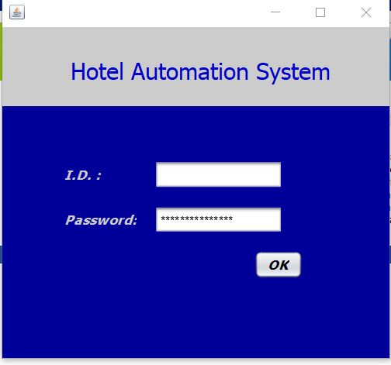

***In the 2nd stage, when you enter the information such as the reservation date, number of people, type of room, the reservation persons are listed in the right part of the same window.***

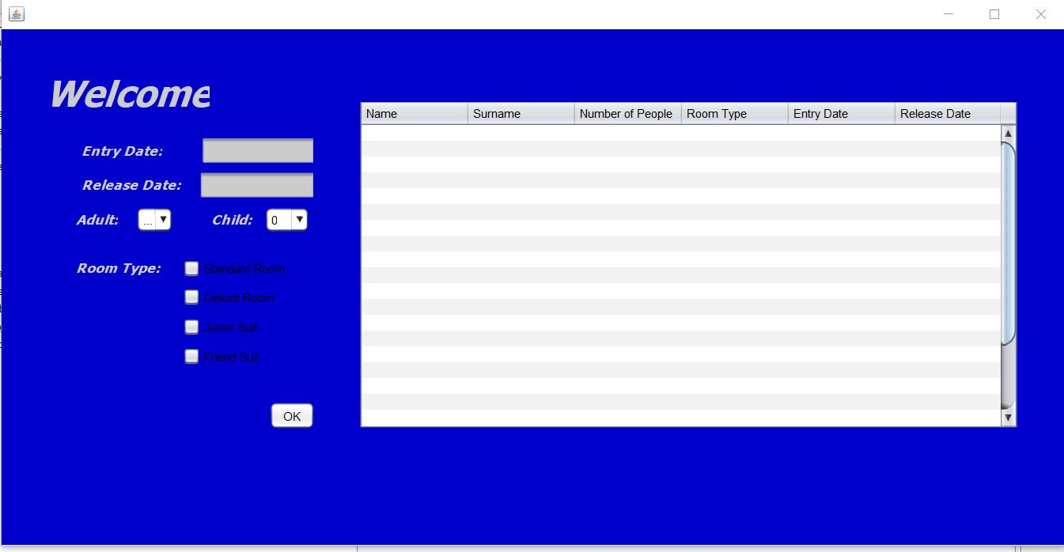

***3. Stage reservation confirmation phase. Here comes the option whether we want to confirm the reservation or not. If we do not approve the reservation, it sends us to the 2nd stage, the reservation screen.***

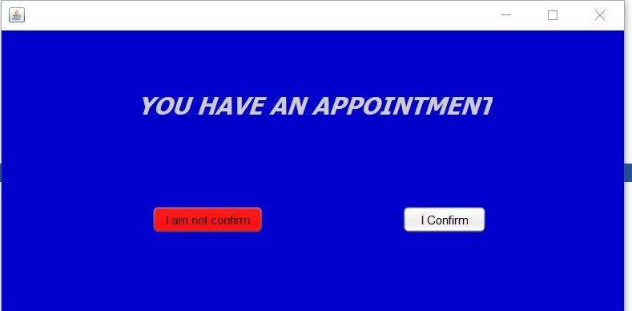

***If we approve on the screen at the last stage, we have a good holidays screen***

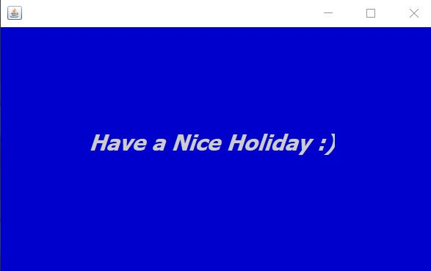

***The codes I used when creating this system:***

1:

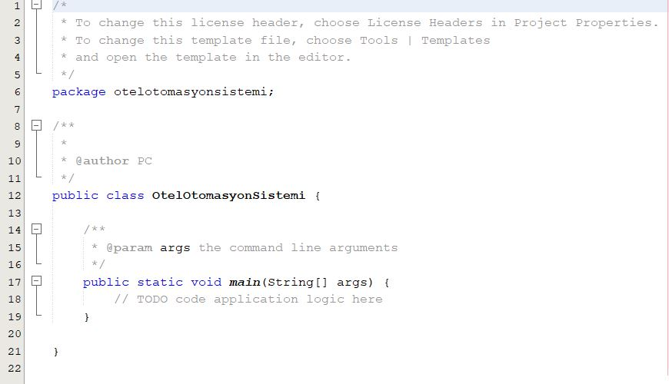

***Login Page:***

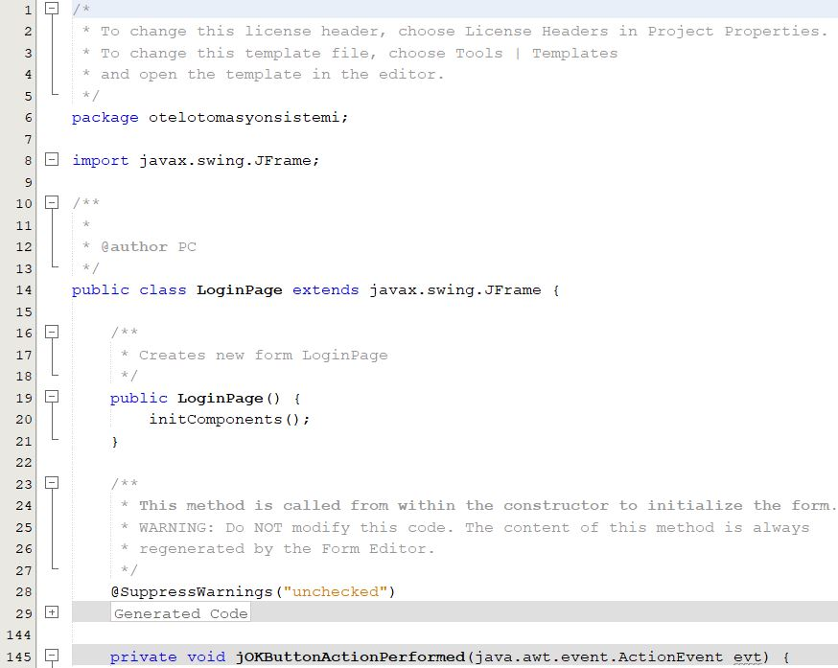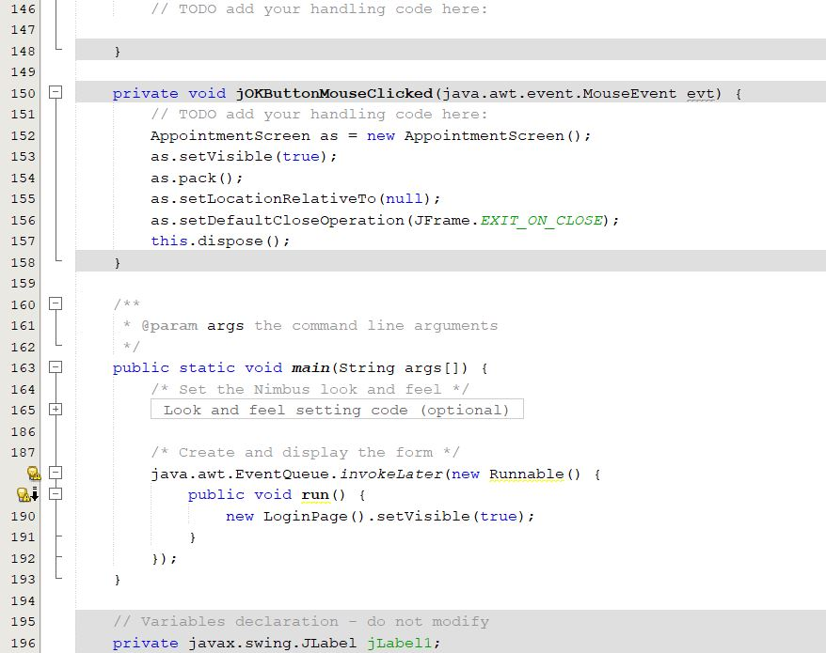

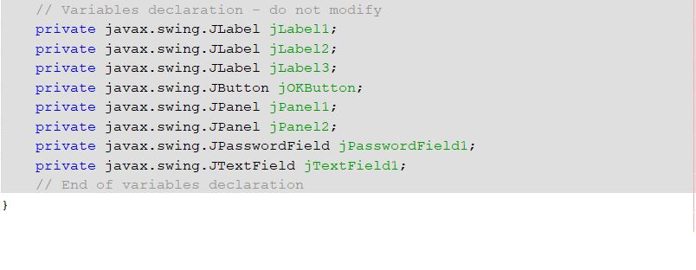

***Appointment Screen:***

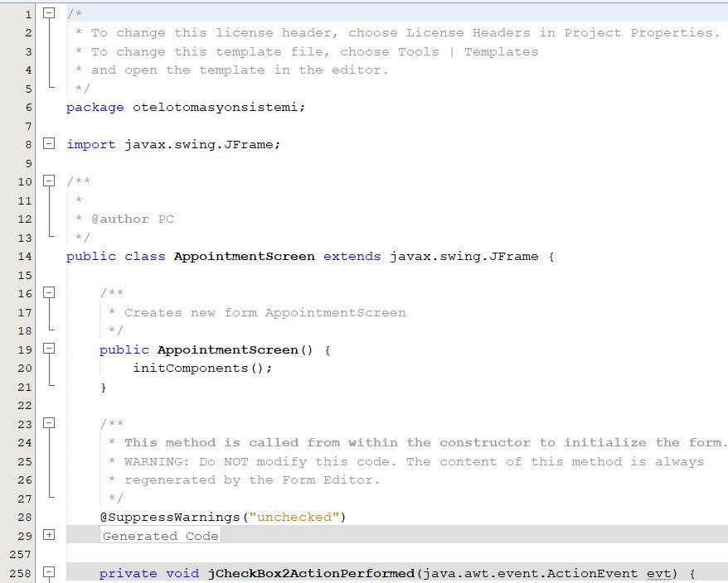

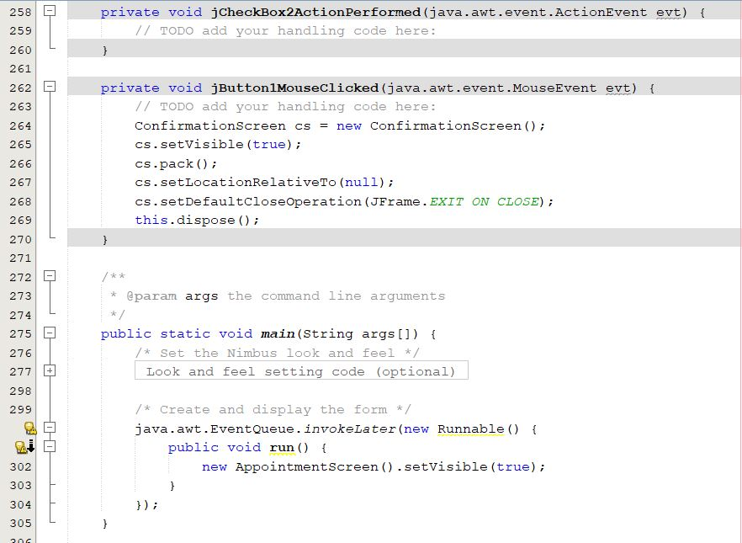

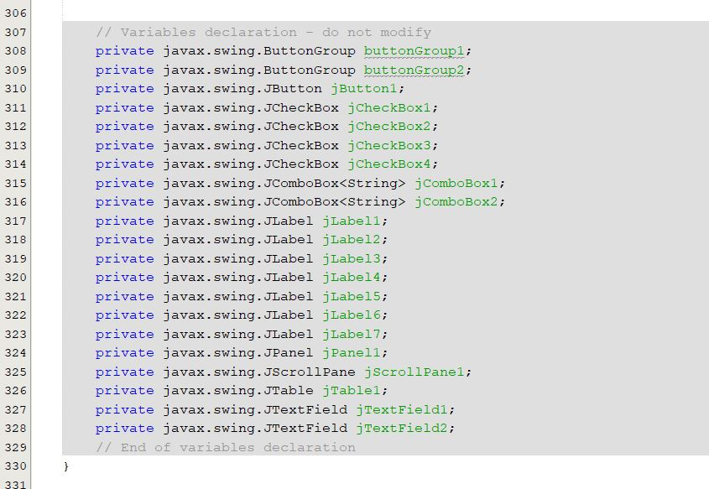

***Confirmation Screen***

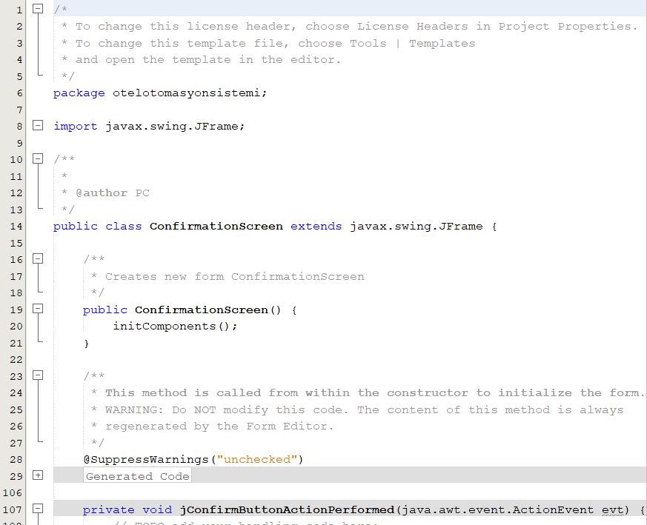

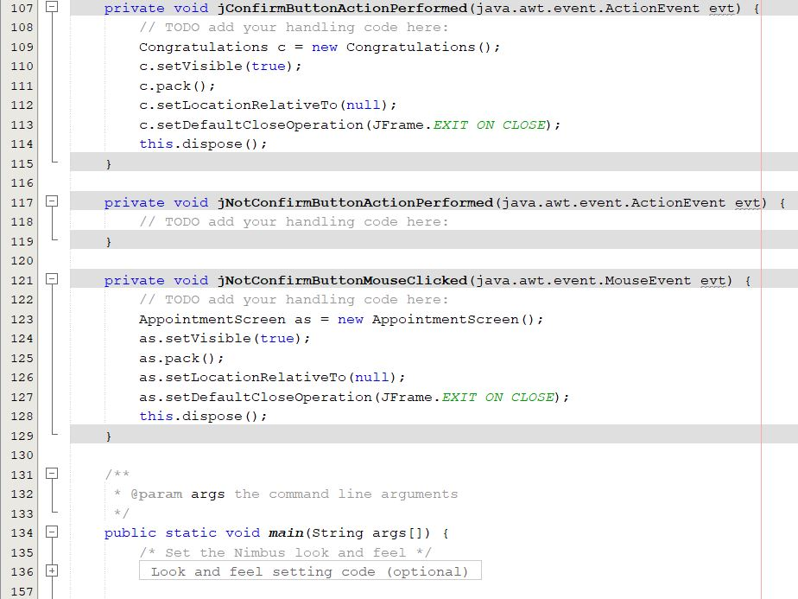

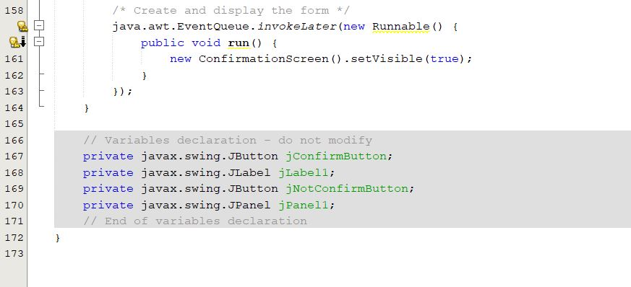

***Congratulations:***

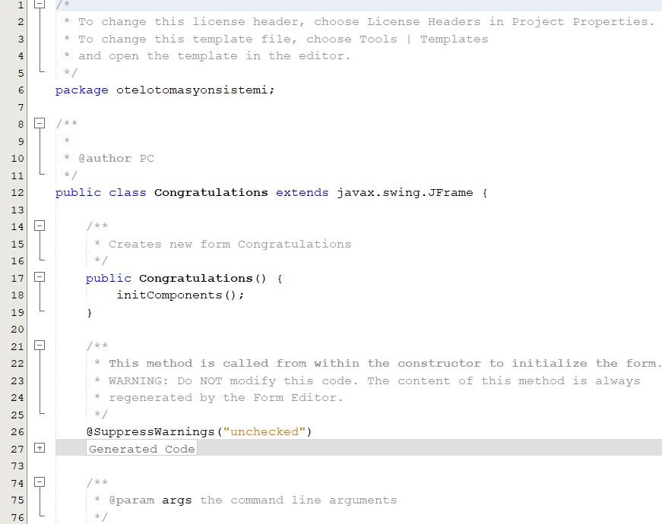

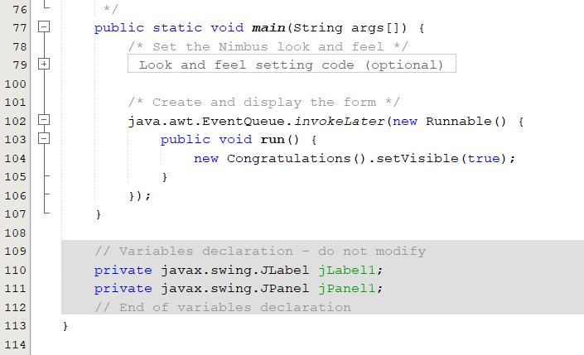

***Note:***

I couldn't make sql connection in the project. I'm very sorry for that, teacher. I add the parts that I made to get information about the report